**NAME: AQSA TAUHEED (2303.KHI.DEG011)**

**PAIRING WITH : Mohammad Hussam (2303.KHI.DEG.020)**

**& MAVIA ALAM KHAN (2303.KHI.DEG.017)**

**ASSIGNMENT NO : 4.3**

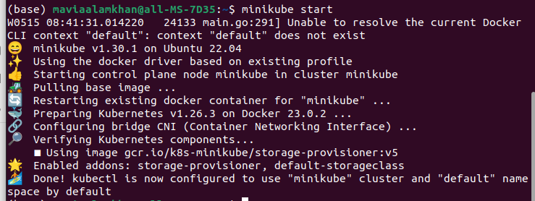

minikube start is used to start a local Kubernetes cluster using Minikube. Minikube is a tool that allows you to run a single-node Kubernetes cluster on your local machine for development and testing purposes. When you run the minikube start command, it sets up and starts a virtual machine that hosts the Kubernetes cluster.

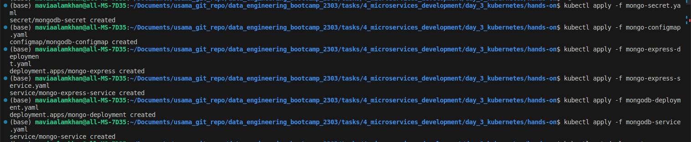

Now we break down the command and its purpose:

kubectl: It is the command-line tool used to interact with Kubernetes clusters.

apply: This command is used to create or update resources in a cluster based on the configuration provided.

-f mongo-secret.yaml: The -f flag indicates that the configuration is specified in a file.

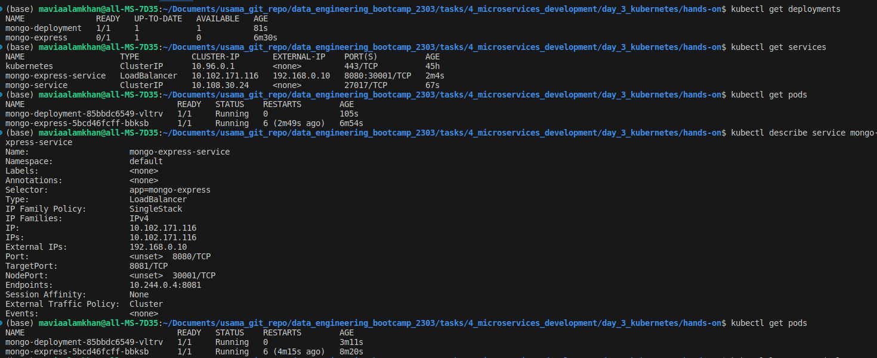

kubectl get deployments, it sends a request to the Kubernetes API server to retrieve a list of all the deployments in the current context or namespace.

kubectl get services, you will receive a tabular representation of the services in your cluster he cluster IP address, and the ports exposed by the service.

kubectl get pods allowing you to monitor their status, resource usage

kubectl describe service command provides a detailed overview of the specified service, including its configuration, status, and associated resources. It is useful for troubleshooting, verifying the service's setup, and understanding its connectivity within the cluster and to external entities.

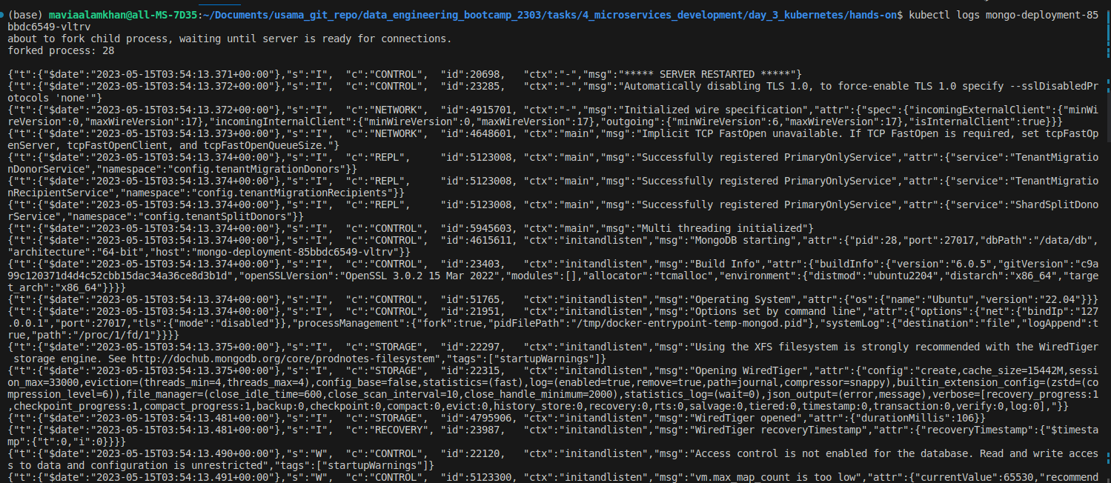

kubectl logs mongo-deployment-85bbdc6549-tgv79 allows you to view the specific pod's logs, which can help you diagnose issues, monitor application behavior, and gather insights into the execution of the containerized application within the pod.

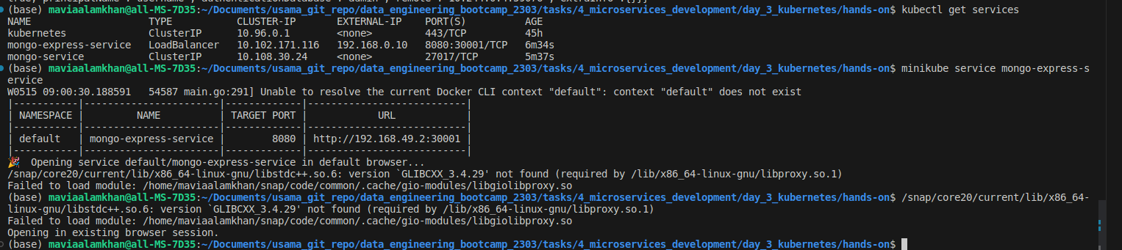

minikube service mongo-express-service deployed on a remote server. This allows you to test, validate, and interact with the service using the full functionality of the application or

interface exposed by the service.

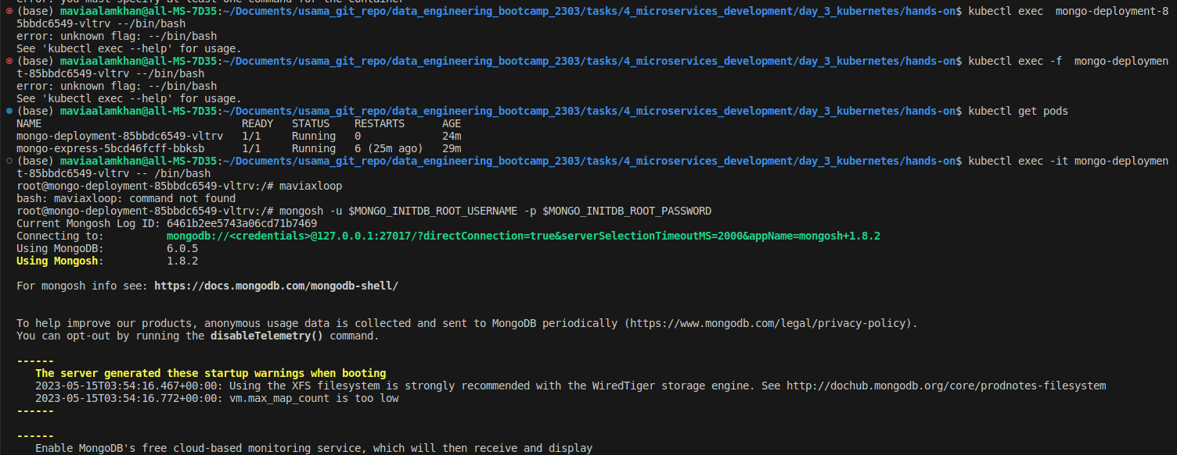



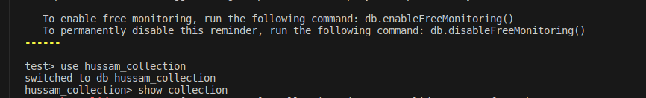

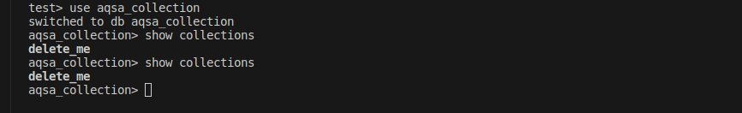

DATA BASE :

